A single mom stepping out in faith into the world of foster care

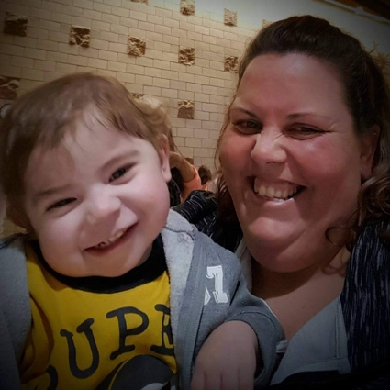
As a single mom of 2 teenagers I was in a job I hated and praying to God to show me what he wanted me to do with my life. Although I didn’t like the company I worked for, I had good work ethics and was going to work hard in the job that I had until God let me know when he had something else for me. After two years and many interviews later, I was very discouraged that the latest job I interviewed for I was not offered. It was within 5 miles of my home, perfect hours and doing pretty much what I was currently doing but for what I thought was a better company. I was not offered the job that I was more than qualified to do. I was so upset and didn’t understand why I wasn’t getting these jobs I was applying and interviewing for. I continued to pray and ask God for guidance even though I was unhappy and not understanding what was happening in my life.

Then God stepped in. Less than 24 hours from the latest job rejection, I received a call that changed my life forever. It was the end of February 2016 and my cousin Bridget called me and asked me if I would consider doing foster care for my two year old distant cousin that was currently in the hospital. Without any hesitation and knowledge of what was going on with this two year old I said YES! Bridget did not know that I was looking for God to tell me what he had planned next for my life. She also did not know that I had always thought of doing foster care. No one did. It was always something I dreamed of doing when I would get married. That my husband and I would make sure that the kids we fostered knew that they were loved, especially by God. And that each and everyone deserves to be loved. Never would I have ever imagined of being a single foster parent. God knew better.

Adrian was his name. A two year old, 15 pound, malnourished, neglected little boy that was slowly dying. A boy that could not sit up because his biological parents ignored him to the point that they did not know he no longer could sit up. He was confined to the baby swing that he spent 24 hours a day in. A child that was born with a heart condition and fought to live since he took his first breath. In dire need of constant medical attention, tube feedings, physical therapy, occupational therapy, speech therapy, and multiple medications several times a day. All which he was not provided while in the care of his biological parents.

Adrian’s wonderful medical team helped him get stable enough to have his much needed 2nd heart operation. It was a year overdue, but by the grace of God it was a successful operation. Now Adrian was ready to learn all what we had to teach him. From that point on there was no stopping Adrian. He worked hard every day to show everyone what he was dying to do, literally. To Live.

A few weeks later on April 12th, after a lot of learning about Adrian and his needs it was time to take him home. I took a leave of absence from my job, using FMLA. One in which I would not have been eligible for if I had recently changed jobs. God had a plan all along and I am glad I was obedient and waited for him to tell me when it was time. It was now time. Time to bring Adrian home. Time to work hard at teaching him skills he had only dreamed of. Time to love him like no one else has ever loved him before.

From day one I started teaching Adrian sign language so that he could start communicating with others and tell us what he wanted instead of covering his eyes with his forearm, crying and pointing to try to tell others what he wanted. Like everything else Adrian did, he caught in quickly to sign language. He learned over fifty signs that he used to communicate his needs and wants. He then started using his voice. Learning single words and then low and behold, singing in the van when traveling to his many weekly appointments. It was the most beautiful sound ever.

Adrian had at minimum 4 appointments a week. He would go to therapy for speech, physical therapy and occupational therapy. Then add in the appointments to the cardiologist, lung specialist, disability specialist, endocrine specialist, genetic specialist, and pediatrician. Then we had a home visit and a school specialist make weekly visits to our home. He was a busy boy, but we were determined to help him get the care he was entitled to.

When Adrian wasn’t busy with appointments he loved spending time outside. He enjoyed learning and trying new things with the other neighborhood kids. Riding bikes, swimming, sprinklers, splash pads, swinging, fishing, and playing all different types of musical instruments were some of his favorite things to do. He was finally able to be a kid and explore and interact in the world around him. He was encouraged to try new things, and like most kids after the initial hesitation, he was in love!

Adrian loved going to church. His favorite job was greeting as a family. Welcoming people into church with his multiple Hi’s, adorable smile and cute waves. He loved to lift his hands towards God and say “Praise Jesus”! During Worship, he always needed to see the lead singer. He would let me know if he couldn’t see her and made sure that we moved so he could see her again.

The neglect that Adrian had endured with his biological parents was catching up with him. He was found to have permanent pulmonary damage now due to his heart working to hard for too long when not given the proper medical care. He was going to have to undergo another heart surgery before the doctors could try to treat the side effects that he was living with due to his pulmonary damage. Adrian was a trooper and successfully made it through another heart surgery on September 7th.

Adrian’s worked hard recovering from his latest surgery. After several weeks, Adrian was called home to heaven. While it has been difficult for me and my family, we all know that he is up in heaven and no longer suffering as he did on earth. Many people ask if 2016 was the worst year of my life and I say on the contrary. It was a privilege that God asked me to be Adrian’s foster mom. I had the opportunity to teach Adrian about God and what love felt like. He was able to feel loved and love others for the first time in his life. I am comforted knowing that he has this is his life and that one day we will see each other again.

I will foster again. I want to ensure that everyone knows that they are loved and they are all here for a purpose. While Adrian’s was more medically fragile than many foster kids, they all have one thing in common. They all want to be loved. Being single should not stop you from being a foster parent. God will provide and make it happen if this is something that you feel in your heart you are called to do. Pray about it. Ask God to make it clear on whether or not this is what you are to do. Feel free to reach out if you have any questions.

To reach Rose: rose@afctravel.com

