A Unique Identity? by Kris Swiatocho
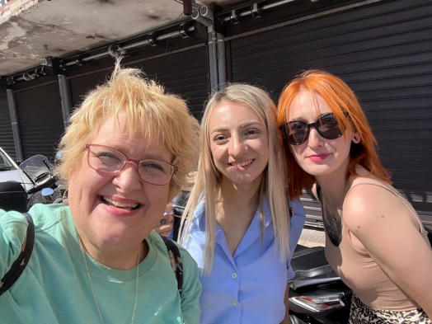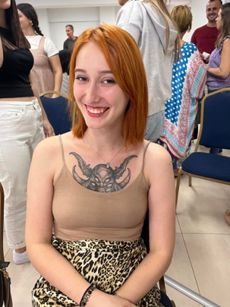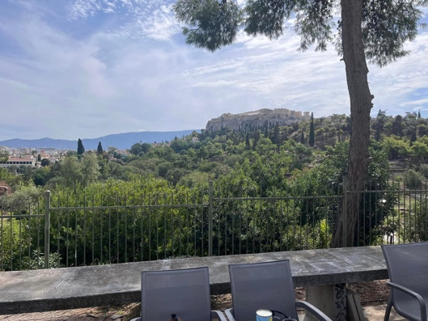

I recently returned from a mission trip to Europe. In my first week, I ministered at Logos Church, led by Pastor Ilias and Bruna Gkionis, in Athens, Greece. I got to speak on their young singles, a thriving group in their church. However, early that day, I was honored to walk around Athens with two young adults, Dena and Electra. Both of them shared their stories with me. Dena was in a new relationship and learning to steer those waters, praying and thinking about the next steps toward marriage. And Electra, wow, let's just say I was overwhelmed by her incredible story.
When Electra walked up to say hello and said she was happy to meet me, I noticed this massive tattoo of a demon across her chest. I was taken aback and quickly asked what was up with the tattoo. She was more than eager to share her story.
She shared how she was raised in a broken family. In her teen years, she longed to find her identity. She desperately sought to see people caring, loving, and accepting of her. The only group that reached out to her was a group of Satanists. At first, all was wonderful, and they seemed to understand her. But then things went downhill. At first, she was required to sign her name on Satan's contract with her own blood. Then, slowly, they would manipulate her into doing some horrific acts. She also found herself doing drugs, cutting herself, and being starved to death. She was now worse off than before. What could she do? Where could she turn? How could she get away from this evil group?
At the same time, she was involved with this group, some Christians were praying specifically for her. And eventually, they connected with Electra, offering her a new identity in Christ. She said she accepted the Lord as her Savior, and everything changed. She would have the power of the Holy Spirit to break free from the chains of the enemy and his followers. She now has the Holy Spirit living in her, and the enemy has no power. She joined Logos church, got into a Bible study, and is now healthy and thriving. She even joined the worship team.
So I asked Electra, then why do you keep that tattoo? Why not get it covered up? She then pointed to her chest and said, this is my story, Kris. Everywhere I go, people ask, and I get to tell them about how Jesus saved my life, literally, and how he can do the same for them.
Wow, I thought, did I have anything on my body that people would ask about so I could tell them my story? I don't have anything physically, but we can all have it in other ways. How we behave, handle stress and conflict, spend our time and money, and treat others reflects who and what we believe in. It can open the door to sharing your story.
So, where is your identity? Is it only in your home, work, stuff, family, and friends, or is it with Christ? Knowing who you are in Christ and rebuking the lies of the enemy will help you in all relationships, including the Lord.
Electra is a new creation in Christ. The old is gone, and the new is here. Thank you, Electra, for sharing your story of triumph over evil.
Therefore, if anyone is in Christ, the new creation has come: The old has gone, the new is here! 2 Corinthians 5:17 (NIV)
To learn more about growing in the Lord and with others, go to www.IntentionalRelationshipSolutions.org and order your copy of Intentional Relationships for Singles' 12-week study.
Kris Swiatocho is the Director of The Singles Network Ministries and Kris Swiatocho Ministries. She has been in leadership for over 30 years, helping countless churches to start and grow their ministry. She is the author of several books, including the leadership curriculum.

• www.TheSinglesNetwork.org
• www.KrisSwiatochoMinistries.org
• www.LaborDaySingles.org
• www.IntentionalRelationshipSolutions.org

