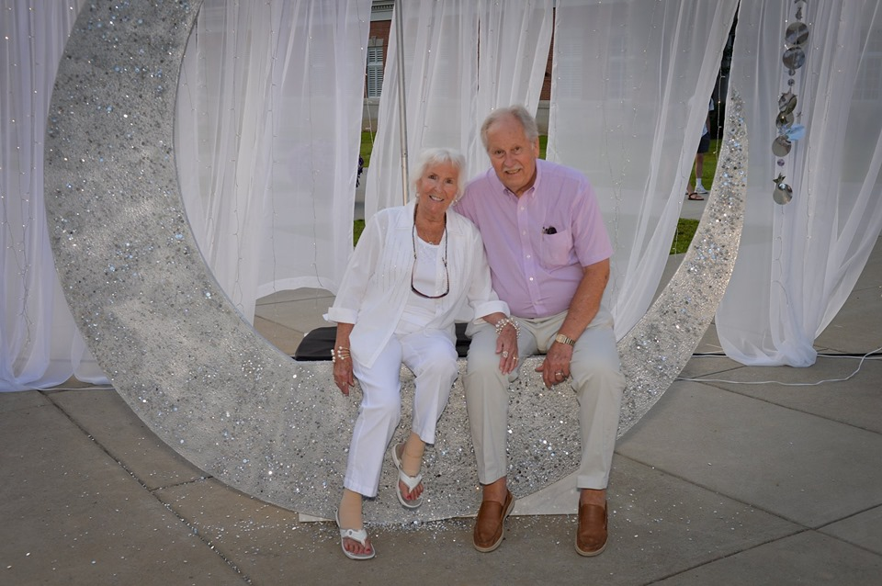

A Light in the Darkness

Recently a friend and I traveled to southern Florida to help with Hurricane Ian relief through Samaritans Purse. On the first day, we were assigned to help with the mud out of Tim and Delores's (Dee) Bokmuller’s home. Tim and Dee lost 99% of their home’s contents, including their car.

Our director told us a little about Dee and Tim and said they would visit sometime that day. Unlike some homeowners, who would be there to help with the cleanup, Dee and Tim were in their 80s and struggling with some health issues, so we understood.

About mid-day, Tim and Dee came to visit, and we had the honor of getting to know them better. Tim got out of the car and walked around to see our work and the few things we could salvage. I didn’t know it then, but Dee used a wheelchair and was on oxygen, unable to get out of the car. She had been diagnosed with Stage 4 Lung cancer almost a year ago.

Our group of volunteers surrounded Dee and Tim, introducing ourselves by name and where we were from. Then a couple from Texas sang them a worship song. We then prayed together. Dee kept thanking every person over and over. She quickly grabbed my hand, telling me how appreciative she was for helping them out. She said it was overwhelming to think it was all gone. She was thankful to her neighbors who rescued her and her husband from the storm. She wanted to make sure we saw the video on her Facebook page.

As everyone else stepped away, I got a chance to talk to Dee and Tim longer. It was then that she shared her story of how she met Tim. They had only been married 16 years. She was 71, and he was 63. They met in church. She was involved in a single lady’s ministry called “OWLS: Older Women Living Single.” By the way, she said I could have that name. LOL. She had been married and raised a family but was not looking to remarry at 71. At the same time, Tim was a widower and had raised his family too. However, unlike Dee, he wanted to be married again. Tim was visiting her church when they met. They first start as friends. Tim would win her heart, and they married a year later. As they both drew closer to God, they grew closer to each other. This was evident to me as I watched them interact.

Fast forward 16 years later, Hurricane Ian would only bond them together more. While God can replace all our things, their love for each other and God was stronger. God had gifted them in different ways. Tim was the behind-the-scenes, get-it-done kind of guy, while Dee was all about witnessing and loving on people. They balanced each other well. On the day of the Hurricane, Dee had taken off her wedding rings in preparation for bed. The storm proved to be much worse than expected, and the 7 feet of flood waters would quickly wash them away. While devastated, she told me it was just stuff, and it was OK. She had given it to God.

Since my trip to Florida, I have kept in touch with them, calling every few days. They had become like grandparents to me. Then early in December, Dee started to have some new pains, and they discovered cancer had spread. Tim knew unless God performed a miracle, her death would be soon. He knew how much her wedding rings meant to her. So, he took old jewelry he managed to salvage from the storm to a jeweler and had him make a new wedding ring for her. The day the ring was ready was the day Dee fell into a coma. Tim placed the ring on her hand, renewing his vows to her. Dee would run into the arms of Jesus two days later.

Tim called me that day to tell me of the news. To say the least, he was devastated and had hoped God would heal her. He told me how much she loved God and she was the strong one in their marriage. Of how he wasn’t sure what he would do without her. I just listened as I knew it had to be so hard. I encouraged him to tell her story like you are reading it now. She was the light in such a dark world, representing Christ. She had a choice to look at all her struggles through the lens of self or Christ. She chose Christ, and so can we all. Thanks, Dee, for the short time of knowing you and your impact on me. Thanks, Tim, for your faithfulness and commitment to her and Jesus.

