Harvests of Kiddos: Ministering in Panama
By Amanda R. Allen

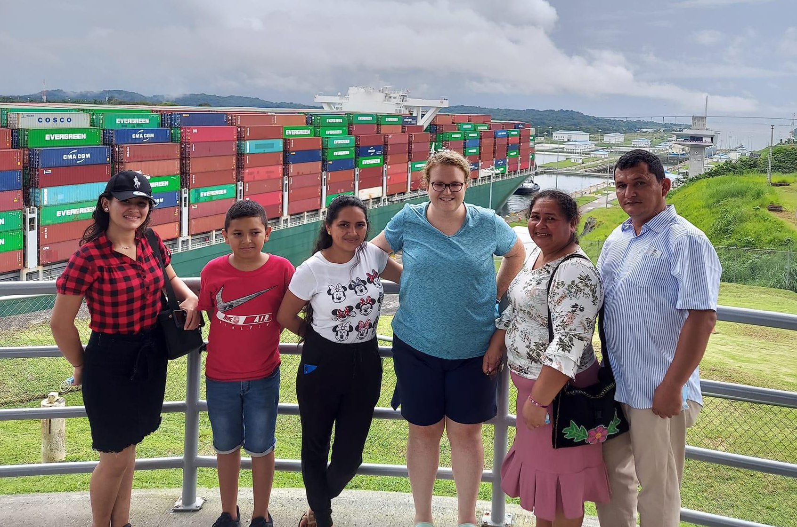
God called me to minister to children many years ago, and I have done my best to serve my "harvests of kiddos," as I like to call them. I have been an educator for over ten years and currently work as a nanny. In November of 2021, God expanded my "harvest of kiddos" to include kiddos in Panama.

GETTING THERE
In 2018, a missionary, Cristobal Yanez from Santiago, Panama, visited my church in Edmond, Oklahoma. He shared his ministry, and his work with children stood out to me. Brother Cristobal was a former school teacher and wrote a Bible curriculum for Panama's public education system. The government permitted him to distribute it within their schools. I loved what he was doing, especially with the children, and wanted to be a part of it. I followed his ministry on social media, received his prayer letters, and became a financial supporter of his ministry. I looked forward to an opportunity to visit and serve the children in Panama.

GOING
In November of 2021, I was able to go for nearly three weeks. I was excited to see Brother Cristobal again and to meet his family, but most of all, I was looking forward to meeting the kiddos face to face and serving them. Soon after I arrived, I met the rest of the family, Brother Cristobal's wife Eneyda, three daughters: Dyanis, Ester, Keren, and his son, Samuel. Dyanis is married and has a young daughter, Melody. Her husband, Wide, is the pastor of the church in Santiago. I immediately felt their love for each other and the Lord. I also met Ruama, a woman from Mexico who was staying with the Yanez family serving in the music ministry. We bonded quickly as single women in our thirties with a heart to serve the Lord. The Yanez family also hosts other young adults to disciple them in the faith and train them for service in the ministry. I could see God at work within this family.

SERVING
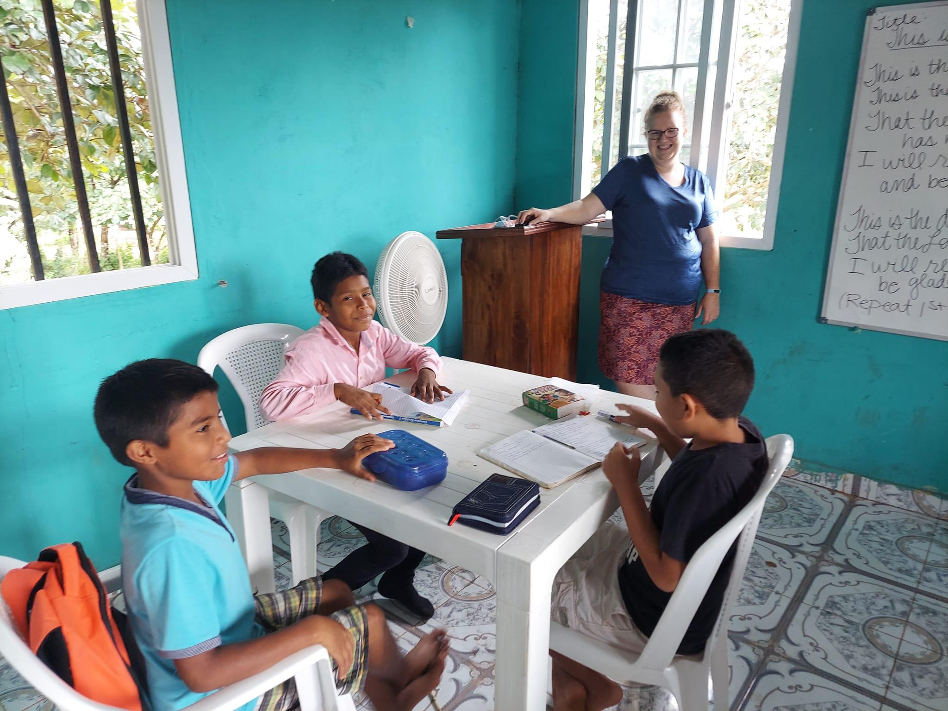
The school year in Panama was winding down for summer, so the routine was a bit more relaxed at Camp El Eden in Cañazas. The learning is online due to COVID, and Ms. Eneyda communicates with the children's teachers to make sure they meet their requirements. I taught some girls the English words for some of the emotions and the five senses. It was a bit difficult at first due to the language barrier, but we made some progress. I also spent one day as a videographer for some of the older students' physical education components. We celebrated the end of school with a fiesta for the students. The children sang and performed music for their families. November is a time of celebration of Panama's independence, and I participated in a worship service dedicated to honoring their independence. They celebrate Mother's day in December, and I participated in a service at the church in Penenome in which the members honored their mothers. It was great to experience the culture and these celebrations.

LESSONS LEARNED
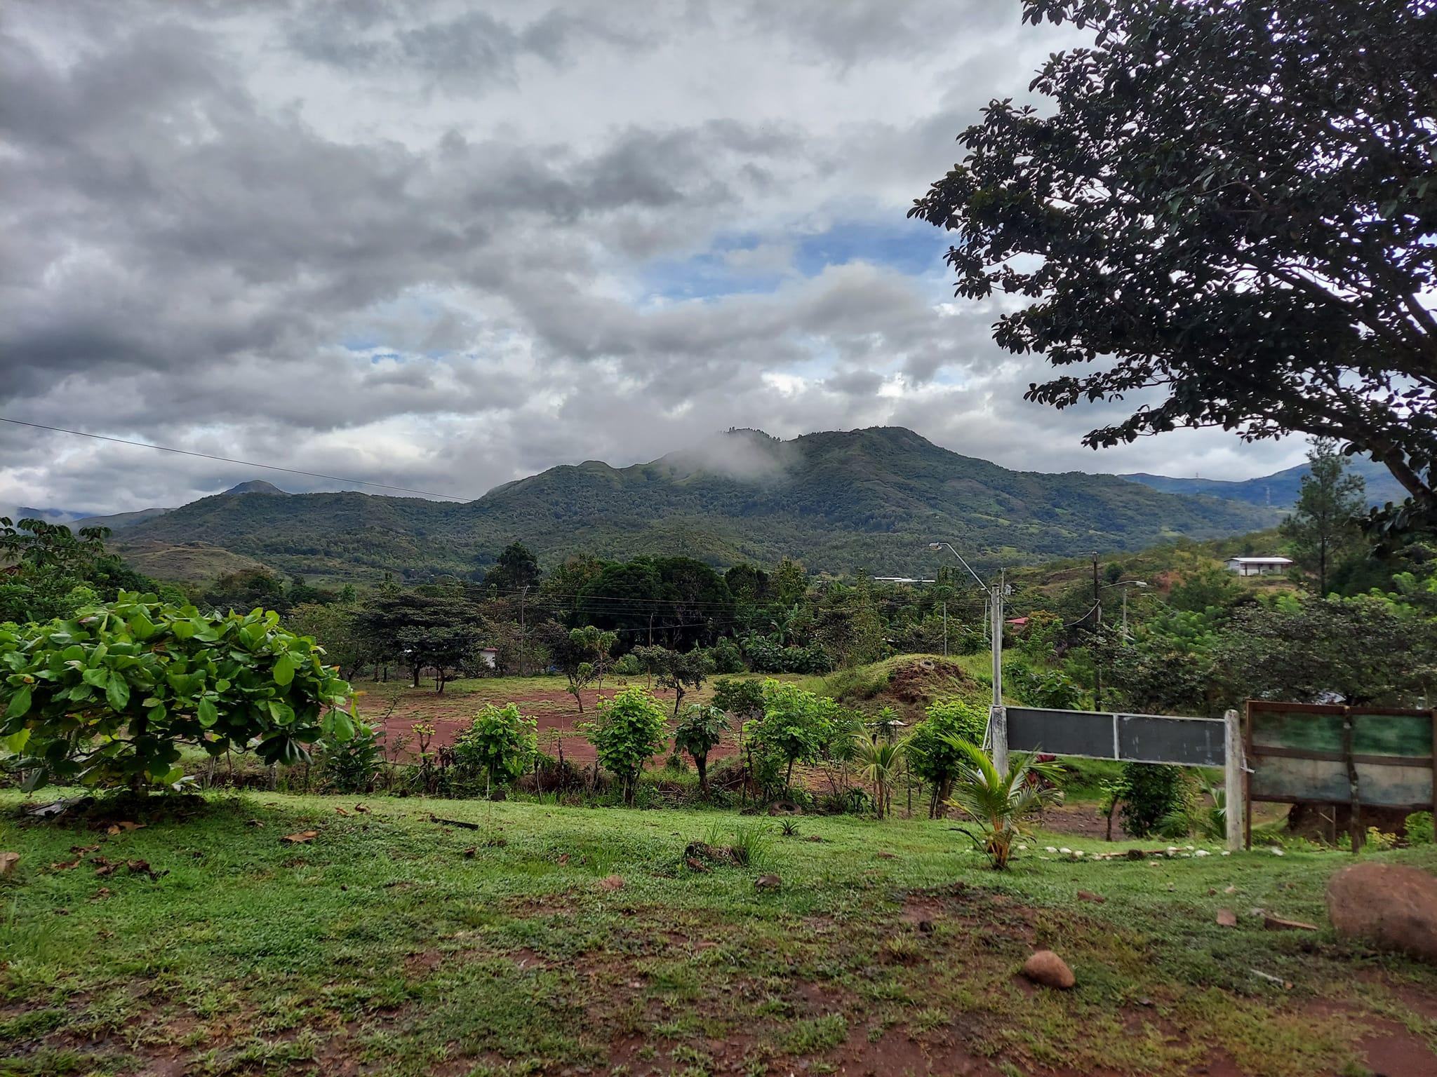
The mission is the same: go and make disciples. We are to tell others about Jesus right where we are planted. God gifts us in particular ways to share Him with those around us in our everyday lives. The culture is important, and it is best to embrace it. The Panamanian daily routine is relaxed. Whatever is scheduled for the day will happen when it happens. Meals are an experience to be savored. The preparation process can take hours, but working together and the fellowship around the table makes the work worth it. This showed me that life doesn't have to be rushed. I can slow down and enjoy the process. As a single adult, I could go and experience a new culture and expand my harvest of kiddos. I didn't have as many responsibilities keeping me in one place. My job as a nanny offered me some flexibility by working my trip around the holidays. I highly encourage you to serve and experience another culture if you can. It will show you what is truly important in life. Remember, the mission field is where you live. Use your gifts where God places you, and share the gospel with people you encounter in day-to-day life. If the opportunity arises to go minister in another country, take it. You will be able to serve God and experience life in a whole new way.

Cristobal Yanez
Santiago, Panama
Facebook: Instituto Educativo Cristiano
https://www.facebook.com/institutoeducativo.cristiano
Instagram: cristobalmyg
https://www.instagram.com/cristobalmyg/

Amanda R. Allen
Facebook: Amanda Allen
https://www.facebook.com/amandaruth13/
Instagram:
doublea374
https://www.instagram.com/doublea374/
arallen374@yahoo.com

arallen.com (coming soon)

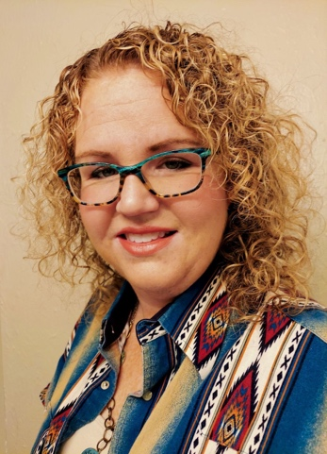
About the Author:

Amanda R. Allen is a single 37-year-old girly-girl becoming a woman after God's own heart. She's ministered to children for over a decade as an educator and affectionately calls them her "harvests of kiddos." Currently, she works as a full-time nanny for individual families. She also serves in her local church as a Children's Church educator and 4th & 5th grade Sunday School teacher. She is the Outreach team leader of her Ladies Fellowship. God equipped her with a gift of teaching and with words, and she seeks to use these gifts for His honor and glory. A few of her favorite things are baking (loves the kitchen), books (more of a collector), bowling (owns bowling shoes), and alliteration.

