# Looking through the branches

Zacchaeus House Herald

###### 314 N. Wilson Street, Rock Hill SC 29730 Directors - Sandy Perry -803-448-7355 / Vicki Perry – 704-837-5020

Please see *Articles and events on page 2*

Sandy Perry

February 2014

Volume 1, Issue 1

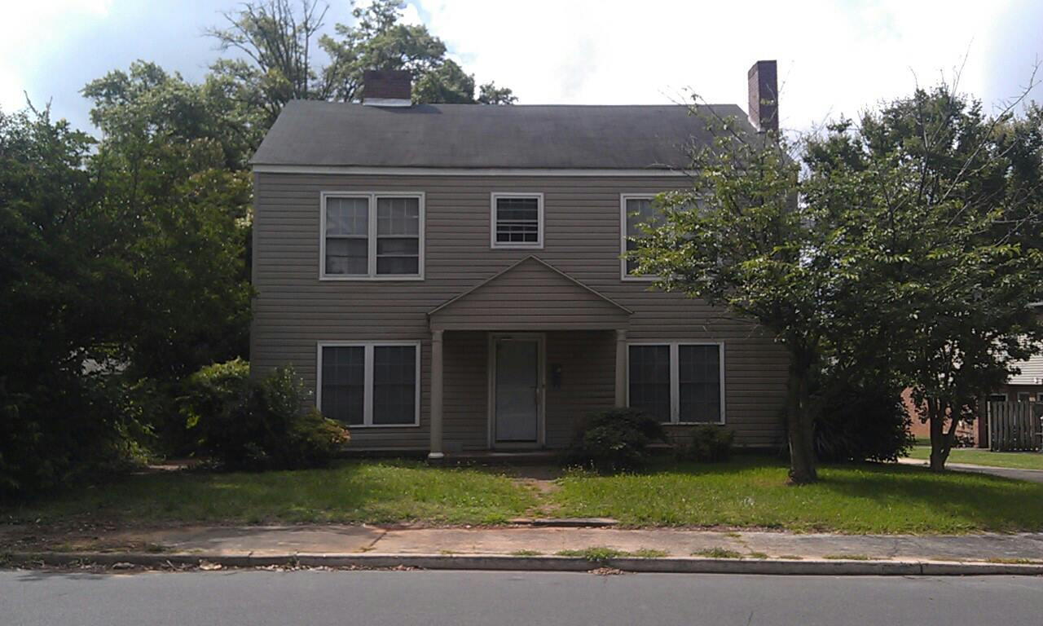

Vicki Perry

For several years the men coming out of prison and into El Roi’s transitional program were housed in trailers. They were housed in pairs separated from each other and directors. God recently orchestrated a number of events to allow the ministry to purchase a house! Now Jermaine, Mark, Steven and Matthew are able to be in community with each other and with us as we grow in faith, love, and service to our Lord. We are seeing God’s plan revealed daily-from those who came to make a house into a home to doors opening in the community for the men and this ministry. God has generously blessed the humble, patient obedience of so many.

Celebrate with us Tim Thompson’s graduation. By doing ‘the next right thing’ day after day, and trusting the Lord to provide, Tim has a new living space, a vehicle, and gainful employment. With the redeeming love of God, through the death and resurrection of Jesus Christ, his life has been transformed. Like many others, he has transitioned form prison to society successfully.

God has generously blessed the humble, patient obedience of many.

Celebrate with us Tim Thompsons graduation! Day after day, one day at a time, Tim did ‘the next right thing and with the redeeming love of God, through the death and resurrection of Jesus Christ, his life has been transformed. He now has transitioned from prison to society successfully as have others in the program.

To God be the Glory!

Come join us as we share dinner, fellowship and Gods word each week. SUNDAYS 6PM

important that the first one or two sentences of an article hook the reader. And since that hook creates an expectation, the article needs to justify the use of the hook, or the reader will feel manipulated.

Along with the hook, the article needs a headline that is brief, active, and clear in its purpose. Beyond these essential characteristics, a headline attracts attention if it is highly relevant, inspires curiosity, or has some other irresistible quality.

Newsletters are short on space and their readers are short on time, so the articles must be well focused, aiming to make one major point. The making of this point can be achieved through two to five (or so) sub-points. These points must have as their primary aim the benefit of the reader, who should be able to point out this benefit. It can be new knowledge or insight, an idea about how to improve business, or better, how your business can improve the reader. The article should clarify, inspire, encourage, enthuse, provoke thought, satisfy—it should elicit a positive response. And the best response of all, of course, is that the reader decides that your products or services provide the solutions he or she needs.

To sum it up, grab the reader’s attention through an effective headline and hook, and then reward the reader for following through by giving something the reader didn’t have before. In addition, keep the article brief and well focused, and if appropriate, demonstrate how your products and services address the issues raised in the article. By doing so, you stand a good chance of keeping the readers you have and gaining new readers with every issue.

# From roots to fruits

God is good and He is good all the time! Zacchaeus house is up and full speed ahead. Vicki and I are so blessed by this opportunity to serve our Lord in His service ‘to the least of these’. We thank God first, El Roi Minstries, the Well Coffeehouse and Church, other churches and all the different ministries that have come along beside us, the encouragers, prayer warriors and people from all walks of life that have given of their time, talents and donations these past few years.

I am sure as we look back through the years we can have a very good sense of how Zacchaeus felt. Always seeking yet never finding, looking for the pleasures and happiness that worldly desires would bring us, just as poor old Zacchaeus thought. But yet like Zacchaeus being up that tree looking and seeking the Lord, we also find ourselves doing the same thing. Then in that moment like Zacchaeus, we find that the Lord has been right there all along knowing where we were to be found. Whether it be up a tree or up a creek without a paddle, He was still guiding the boat, lighting the way and calling us out of whatever tree we were in. Jesus is always seeking to save the least and the lost (Luke 19) and if we are about our Fathers business as He was, we will be also.

Blessings in Christ!

the Task Pane titled “Creating a Newsletter.” You may also be interested in reading “Printing a Newsletter,” which describes different printing options, such as using large paper to print your newsletter as a folded booklet. In addition to these template Help articles, the Task Pane contains links to Help topics related to the Microsoft Word features used in this template, such as text boxes. As an added help, before you begin replacing this content with your own, you may want to print this template to have the benefit of its instructions. *Inside This Issue* lists articles designed to help you write an effective newsletter.

When you create a newsletter, first determine the audience. This could be anyone who might benefit from it, such as those interested in a product.

You can compile a mailing list from business reply cards, customer information sheets, business cards collected at trade shows, or membership lists. You might consider purchasing a mailing list from a company that serves your target customer.

Next, establish how much time and money you can spend on your newsletter. These factors help determine the length of your newsletter and how frequently you will publish it.

### 3

Inserting Your Own Art 2

Drawing Readers to Other Articles 2

An Article for Everyone 3

Fitting an Article into a Tight Space 3

The Elements of a Newsletter 5

UPCOMING EVENTS

**Sunday FEB 23RD at 6 pm**

Dinner and meeting

Learn how YOU can participate in  
 Gods ministry here at the Zacchaeus house

RSVP Sandy Perry - 803-448-7355

Vicki Perry – 704-837-5020

**Gerry Potoka Executive Director, El Roi Ministries**

PTS (Prison To Society) is a faith-based pre-release program sponsored by El Roi Ministries, that was launched in January, 2009 at Kershaw Correctional Institution with 30 inmates participating in daily programming consisting of three principal components: education classes in the morning, life-skills training in the afternoon, and character/spiritual development each evening. The curriculum is taught with a unique mix of inmate instructors, church and community volunteers, and SCDC chaplains and staff, and is blessed to have the continued support and encouragement of Warden Cecilia Reynolds and the entire staff of KerCI. PTS participants voluntarily enter the program and remain until released from SCDC - generally for a period of 6-18 months. It is our desire to prepare inmates to be productive members of society, both during incarceration and after release from prison. While many new ministries flounder during their first years, PTS has grown and prospered. We now have about 90 men enrolled in the program continually and have graduated over 380 men back into society, with a recidivism rate of less than 12%. God is still in the miracle working business and He is using PTS to bring about life-changing transition to many men incarcerated at Kershaw.

After 3 years of using rental trailers for transitional housing, El Roi Ministries has now purchased a 7 bedroom, 3 bathroom, 2 kitchen house in the heart of Rock Hill, SC which will allow up to 12 men per year the opportunity to receive 6 months of seamless integration into society. The Zacchaeus House will be directed by Sandy & Vicki Perry, long time ministry volunteers with a heart to bring the Kingdom of God to broken and hurting people. Zacchaeus House offers a safe, positive, Christian environment, personal spiritual mentors, and support with resume building, job searches, transportation to Celebrate Recovery and weekend worship services, and financial accountability.