Obong Mike Obong
Director/Facilitator of DivorceCare Recovery Ministry in Uganda (www.divorcecare.org) and Senior Pastor at Christ Divine Fellowship Ministries, Lira (Uganda.
I was born in 1979 at a time when Obote II Government was overthrown by Amin, I do not remember the life experiences of that time but I tested a bit of such in 1986 when NRA took over the government, there came Cattle raiders (Karamojong), followed by Alice Lakwena Rebellion and lastly and worst of all Lord Resistance Army under leadership of Joseph Kony, in all these hard days we were hiding in bushes and lived in Internally Displaced Camps.
I gave my life to Christ in 1998 when I was in senior three at Faith Senior Secondary School and the Lord started to use my life to impact others to Himself. To cut the story short, as a result of the above rebellions many prominent men, women and children were either killed or kidnapped. Many children got recruited on the streets because either one or both parents died in the war. The rate of HIV/Aids increased because people were living in severe poverty and suffering. Many women remained widows because their husbands were killed/kidnapped by the rebels.
Many Churches were and are still having the challenge of single parents who are hurting due to divorce/separation, death of loved ones etc. As it has been my desire to be a family Pastor God connected me to Church Initiative (USA) where I serve now as Director for DivorceCare Ministry in Uganda. We train Church Leaders with Biblical skills on how to minister to people hurting due to the pain/trauma of divorce/separation, many Churches in Lira, Kibuku, Pader, Agago, Apac, Kole and Alebtong are now trained and equipped with materials to her them minister to their hurting flock. The dark story about single adults is that the Churches do not have specials ministry for them to be listen to and allow God to be in the center of their lives, much as the Pentecostal churches are trying the best through deliverance services but the impact is not clear because of spiritualizing things. Most deliverance ministries relate with single adults during pulpit time and counseling rooms may are focused on demons but not looking at emotional issues. The devil is a liar and a destroyer but Jesus saves, it takes the wisdom of the Church Leaders to through the power of the Holy Spirit to identify its tactics.
Pastor Thomas is the Senior of Christ Divine Fellowship Ministries, besides evangelism, Church planting, Sunday services and other weekly services; we are training and equipping Churches with DivorceCare materials in order for them to serve hurting people in their communities and Churches.
DivorceCare group members during Facilitators training in Kole district pause for the photo below
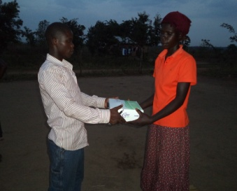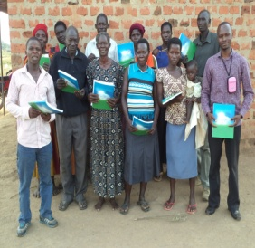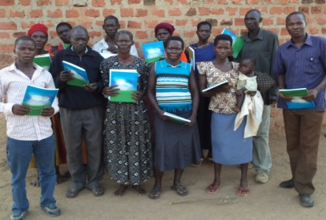Thomas is blue shirt left of the third picture.

Celebration of 2 Anniversary of Christ Divine Fellowship Ministries
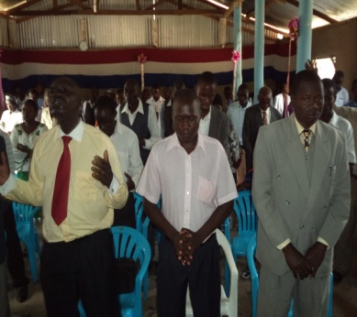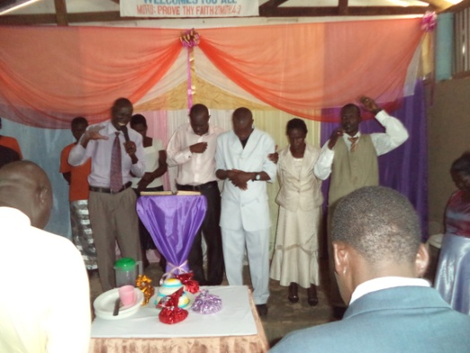

Training of Single adults on positive parenting in collaboration with DivorceCare Recovery Ministry in Lira.
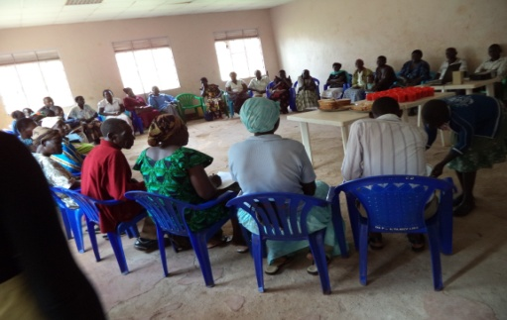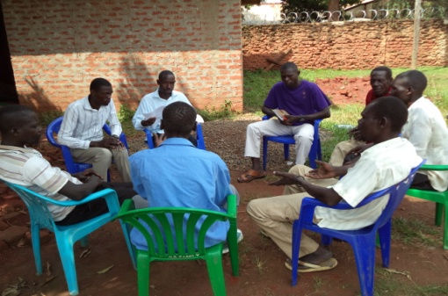

Children from Singles family, some are street children.
